Item | Specification
Clear-span width | 4m
Eave Height | 2.47m
Ridge Hight | 4.28m
Bay Distance | 4m
Wind Loading | ≤120km/h
Minimum Tent Length | 4m
Roof Fixing | bar tensioning
Framework Profile | 48mm*105mm*3.5mm
Eave Connection | Hot dip Galvanized aluminium cube tube
Cover Material | PVC Knife coated nylon fabric; 750g/m²
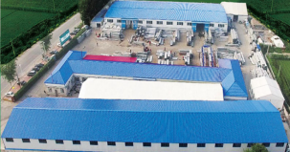 | 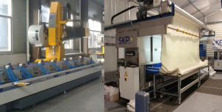 | 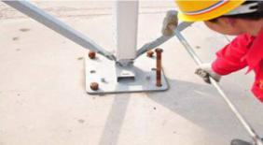

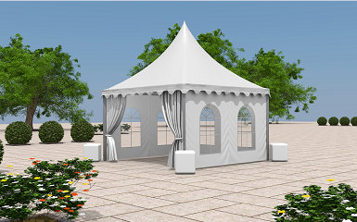
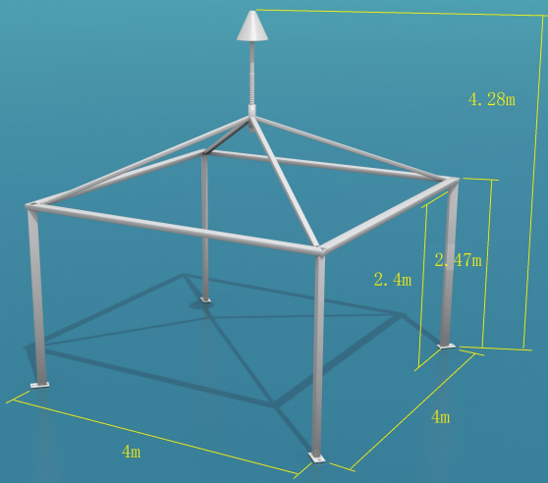
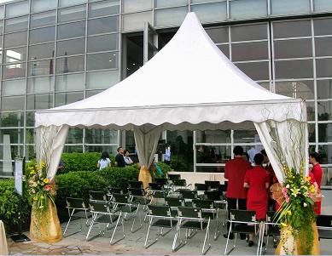内部图
Pagoda Tent Technical Data
Type：4m*4m
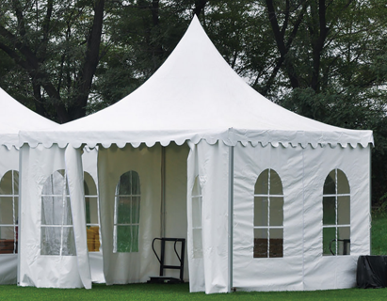

Optional Accessories
PVC window sidewalls
Anchoring
Rain Gutter
Lining and curtain
Glass door units
Hard walling system
Glass walling system
Transparent PVC cover and sidewall
Flooring system
Weight plate
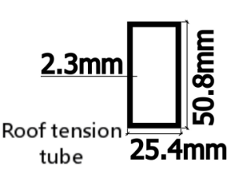 | 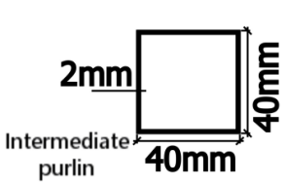
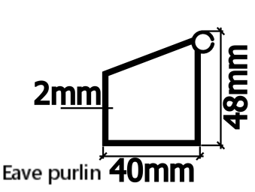 | 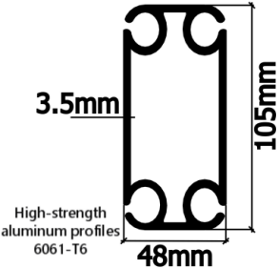
Framework main profile dimension and use

